Contents
What am I making? 1
Extra Resources 1
Sketching my Drawing/Model 2
Converting my Sketch to a Vectored Drawing 3
Opening Tinkercad 3
Importing to Tinkercad 4
Creating the Stencil/Model 4
Exporting the Design 5

What am I making?
At the end of this project, you will have a model or stencil which you can use a helpful tool when you are working on indigenous art. Some examples of stencils or templates for clay models are below.
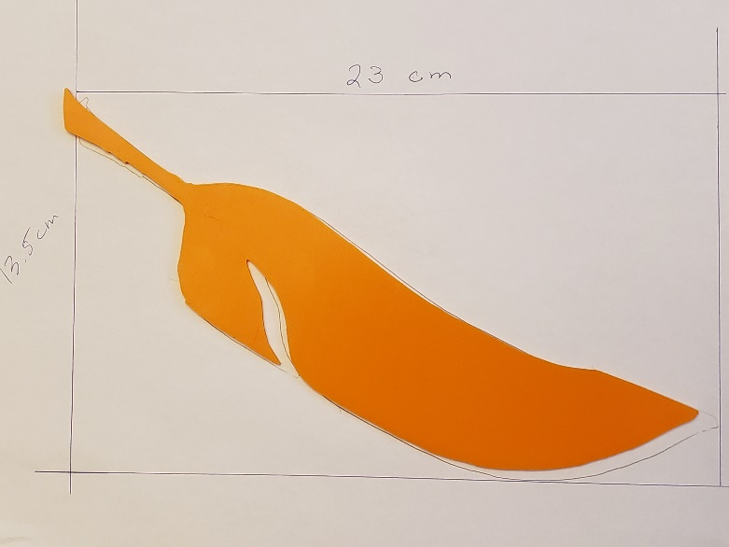
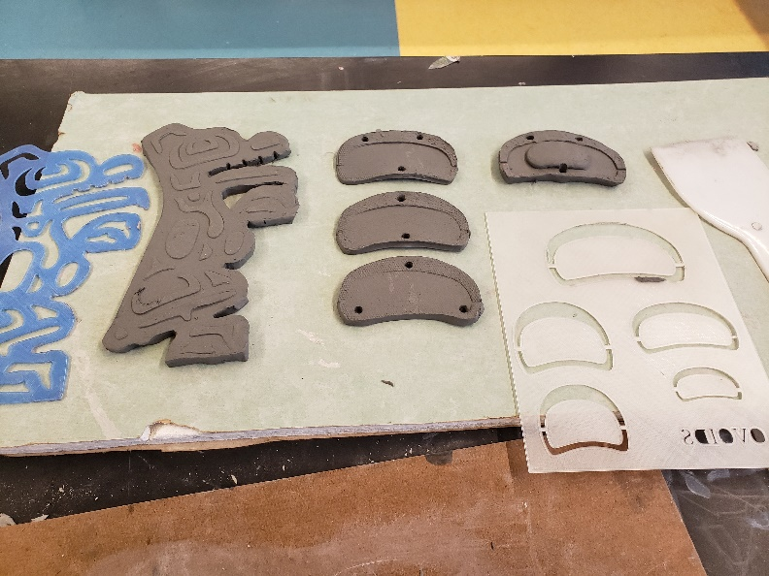
Stencil of a Feather
Clay Models

Extra Resources
Go to Perpetual Salish to see their templates for Coast Salish Design Elements.

Sketching my Drawing/Model
Choosing what shapes or symbols will be your stencil or model is the first part of your design phase. On this page, you can brainstorm or sketch your ideas.

Converting my Sketch to a Vectored Drawing

- Once you have completed your sketch on the previous page (or a fresh piece of paper) scan (or photograph) your sketch. You will have more success if your sketch is created/captured in black and white.
  - You may need to ‘crop’ the image you captured so that there are no extra objects in your image.

- Visit SVGcreator and upload your image. Click convert file, then download your Scalable Vectored Graphic (SVG) file. Make sure you know where the download is going, you will need it again shortly.
  - Online-Convert can be used as an alternative.

Opening Tinkercad

The following instructions should be completed in order!
- Go to www.tinkercad.com. If you have yet to create an account, the teacher will aid you.

- Once logged in, click this link to find the template for your stencil.
  - Click “Copy and Tinker”. Once the page has loaded, this will open your work pane.

- Controls in Tinkercad:
  - Left Mouse click: Select and/or Drag objects.
  - Middle Mouse click & hold: Pan the camera (move up/down/left/right)
  - Mouse Wheel: Zoom in/out.
  - Right Mouse click & hold: Pivot the camera (swing in all directions)

- Before manipulating anything, change the “Snap Grid” setting (in the lower right corner) to its lowest setting, and then proceed to the next step.

Importing to Tinkercad

- Click the import button on the top-right of the page and select your SVG file that you created earlier.
  - Tinkercad will load a preview but may encounter an error if your SVG image is too large. You can alter the scale or one of the dimension boxes to fix this problem.

- Click the Import button, and your object will appear.

Creating the Stencil/Model

- The rectangle on the left of the work pane in the template can act as a stencil base, if required.

- Depending on your intentions, you can manipulate your object several ways while it is selected.
  - You can drag white sizing boxes to change the shape of your object. If you want to maintain the original shape of your object but scale its size, hold onto the shift button on your keyboard while dragging a corner box while your object is selected.
  - You can change the object from a “solid” to a “hole” and back again by selecting the object and clicking your preference in the shape menu.
    - If you wish to create a stencil, scale & move your shape onto the premade rectangle, set your object to the “hole” setting, then select both objects and group them.
- Extras:
  - You can change the height of your object by using the white sizing box that appears in the middle of your object when selected.
  - You change the positional height of your object by using the black cone that appears in the middle of your object when selected.
  - Your can rotate your object by using the arrows the appear around your object when selected.

When you are happy with how you have manipulated your object, move onto the next step.

Exporting the Design

The following instructions should be completed in order!

- Make sure you are currently working in Tinkercad with your design open.

- Make sure your design has a name. Check the top left corner and rename your design if necessary.

- Click the “Export” button on the top right.

- Select “.STL” which is a file type used for 3D printing.
  - The file of your object will download. Depending on the type of computer you are using, the download location will vary. It will be up to you to find it!

- Go to the Stencil/Model assignment in Google Classroom.

- Click “+ Add or create” and select “File”.

- In the “Upload” menu, select “Browse”. Find your design file and select it.

- Click “Turn in”.

- You are done the Export phase, and the teacher can now print your object!

