In this project, you will be writing a poem that will be later expressed in spiral art. To accomplish the project, you will need to complete this planning package.
Contents
Brainstorm 1
Poem Drafts 2
Using Formulas to Determine Ordered Pairs 3
Finding my Ordered Pairs 4
Graphing Ordered Pairs: Practice 5
Graphing Ordered Pairs: Draft 6
Opening Tinkercad 7
Drafting Your Gear in Tinkercad 7
Exporting the Design 8

First, you will brainstorm below then write two poems on the back of this sheet. Poems must:
- Have 8 lines.
- Have a rhyme scheme (ex. ABBA ABBA).
- Be original.
- Be appropriate!
After you have completed both, consult the teacher before moving on to the next step.

Brainstorm

Poem Drafts

Poem 1:___________________________________
________________________________________________________________________________________________________________________________________________________________________________________________________________________________________________________________________________________________________________________________________________________________________________________________________________________________________________________________________________________________________________________________________________________________________________________________________________________________________________________________________________________________________________________________________________

Poem 2:___________________________________
________________________________________________________________________________________________________________________________________________________________________________________________________________________________________________________________________________________________________________________________________________________________________________________________________________________________________________________________________________________________________________________________________________________________________________________________________________________________________________________________________________________________________________________________________________

After checking in with a teacher and showing them my poems, I will be using poem # _________ for this project.

Using Formulas to Determine Ordered Pairs

Formulas are a rule or instruction that we use to calculate something repeatedly.

Variables are used in formulas so that we may apply the formula to different numbers, measurements, or amounts. There are no “right” or “wrong” formulas in this project.

We will create/use a formula set to determine the ordered pairs for each line in our poems. Whether you make your own formula set or use one of the premade sets below, you must only choose one set and stick to it.

Definitions:
Variable: a symbol, usually a letter, that represents that spot/place for a value.
Ex: $x$is a variable.

Ordered Pair: the x,y coordinates on a graph (cartesian plane).
Ex: $(x, y)$is the proper way to write an ordered pair.
Premades:
- $w$= # of words in a line
- $s$= # of syllables in a line
- $l$= the line number
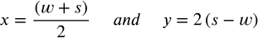
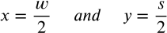
If you are going to use one of these premade sets, HIGHLIGHT the one you choose.

On the next page:
- Indicate the formulas you are using for both x and y.
- Rewrite your poem in the space provided.
- Complete the word and syllable count for each line.
- Apply the formulas & calculate the values for x and y on each line.

Finding my Ordered Pairs
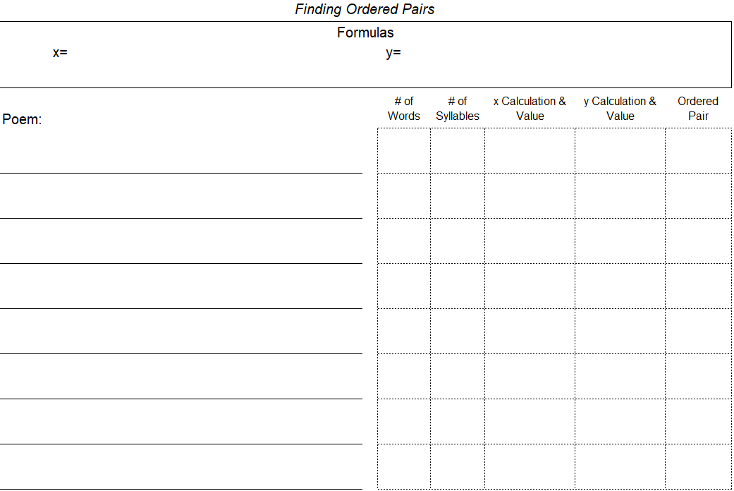

Graphing Ordered Pairs: Practice

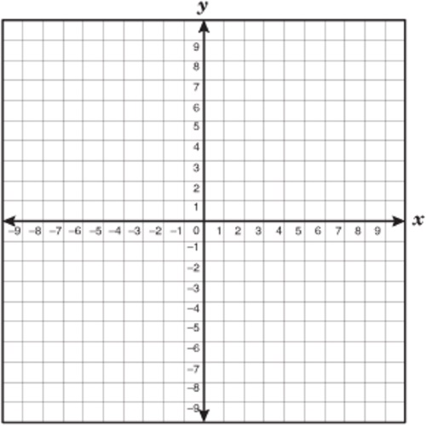
Practice graphing your ordered pairs on this cartesian plane.

Graphing Ordered Pairs: Draft

Graph your ordered pairs on this draft template of your Spirograph gear.

0, 0

Opening Tinkercad

Once you have completed the draft template of your gear, it is time to move onto Tinkercad and configure your digital 3D object.

- Go to www.tinkercad.com. If you have yet to create an account, the teacher will aid you.

- Once logged in, click this link to find the template of the gear. You can also find the link on Google Classroom.
  - Click “Copy and Tinker”. Once the page has loaded, this will open your work pane.

- Controls in Tinkercad:
  - Left Mouse click: Select and/or Drag objects.
  - Middle Mouse click & hold: Pan the camera (move up/down/left/right)
  - Mouse Wheel: Zoom in/out.
  - Right Mouse click & hold: Pivot the camera (swing in all directions)

- Before manipulating anything, change the “Snap Grid” setting (in the lower right corner) to its lowest setting. This will make it easier to move the cylindrical voids.

Drafting Your Gear in Tinkercad

- Using your draft gear sheet, move each cylindrical void to their corresponding points on the plane of the gear. There is a small circle in the bottom left corner that marks the origin.

- Select the initials at the top of the gear and change them to your own.

- Select all the shapes by clicking and dragging a selection box. Then, click the “Group” button of the top left.

- You are done the design phase! If you are having issues with the grouping, some shapes might be too high or too low on the z-axis. Ask the teacher for assistance.

Exporting the Design

Once you have completed the design of your gear, it is time to export the design for printing. The following instructions should be completed in order!

- Make sure you are currently working in Tinkercad with your design open.

- Make sure your design has a name. Check the top left corner and rename your design if necessary.

- Click the “Export” button on the top right.

- Select “.STL” which is a file type used for 3D printing.
  - The file of your gear will download. Depending on the type of computer you are using, the download location will vary. It will be up to you to find it!

- Go to the Spirograph Poetry assignment in Google Classroom.

- Click “+ Add or create” and select “File”.

- In the “Upload” menu, select “Browse”. Find your design file and select it.

- Click “Turn in”.

- You are done the Export phase, and the teacher can now print your gear!

More to come...

