In this project, you will be designing and 3D printing a ruler of your own design. Measuring and designing your ruler can be complicated without a plan, so follow this step-by-step guide to make it easier.
Contents
What am I making? 1
What measurements will I use? 1
Choosing my Stencils & Designing My Ruler 2
Opening Tinkercad 4
Drafting your Ruler 4
Choosing the Correct Shape 5
Exporting the design 6

What am I making?

At the end of this project, you will have a custom-made ruler. It will be 25cm long and feature stencils of shapes that you may draw or write frequently. Below is the teacher’s example.
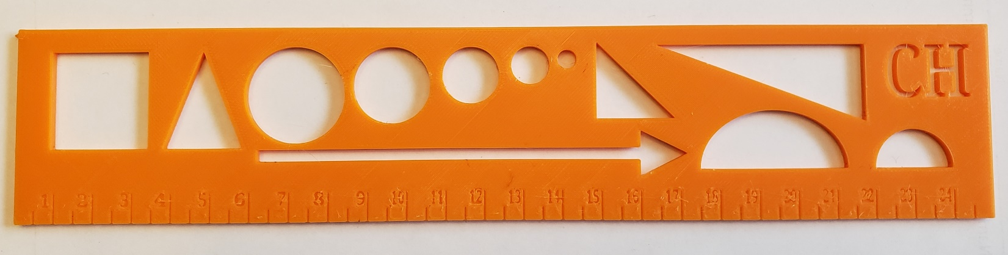

What measurements will I use?

You will use Millimeters (mm) to craft your ruler. As you create a template by hand for your design, you will measure the length and width of each shape in Millimeters. This will allow you to transfer your design to the drafting program (Tinkercad) with relative ease and speed.

Choosing my Stencils & Designing My Ruler
Choosing what shapes will be your stencils (the holes of shapes which you can trace) is the next part of your design.
On this sheet, sketch several shapes or symbols that you use when you write in the box below. The example on the title page has 12 distinct shapes! Some examples include:
Text Symbols: &, %, $, #, @, are symbols that are not used too often and be difficult.
Shapes: Right triangles, Circles, Cones. A stencil can help you draw them perfectly.
Math Symbols: ≤, ≥, ∏
Others: What sort of shapes do you find yourself using often, but never quite write the same way twice?

On the next sheet, a template is drawn with the centimeter notches. You will place your shapes on the template, make a list of the shapes you use, and record the measurements of each shape, in millimeters. Some things to consider:
- Where you place your shapes on your template is where they will appear on your ruler.
- You will have to organize your shapes in a way where they all fit on the template.
- The thickness of the shape matters; a pencil tip will have to fit through the stencil in order for you to trace the shape. Make sure your shapes are at least 3mm wide!
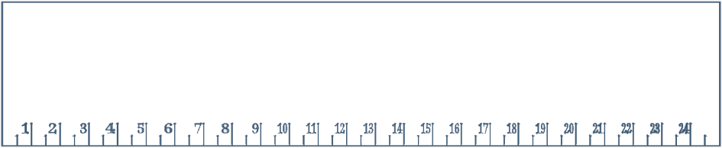
Shape Name: Measurements in mm (Base x Height):

Opening Tinkercad

- Go to www.tinkercad.com. If you have yet to create an account, the teacher will aid you.

- Once logged in, click this link to find the template of the ruler. You can also find the link on Google Classroom.
  - Click “Copy and Tinker”. Once the page loads, this will open your work pane.

- Controls in Tinkercad:
  - Left Mouse click: Select and/or Drag objects.
  - Middle Mouse click & hold: Pan the camera (move up/down/left/right)
  - Mouse Wheel: Zoom in/out.
  - Right Mouse click & hold: Pivot the camera (swing in all directions)

- Before manipulating anything, change the “Snap Grid” setting (in the lower right corner) to its lowest setting. This will make it easier to move the cylindrical voids.

Drafting your Ruler

- Select the initials at the top of the ruler and change them to your own.

- With your template (the previous page), use the “Basic Shapes” menu on the right to create the shapes you planned to have.
  - The ruler’s height is 2.65mm, so use the white sizing box in the middle of the shape to change the shapes height. For easier manipulation, you can click on the box and type the value into the text box.
  - Resize the length and width of the shape in the same fashion to match the measurements on your planning sheet.
  - Some objects will need to be rotated so that you may position them properly. While selected, use the double-sided arrows that appear to rotate the object.

- Move all your shapes to roughly match their corresponding spaces on your template.

- Once finished, drag & select all the shapes in the design and press the group button.

Choosing the Correct Shape

It can be difficult to know which shape available in Tinkercad is the best fit for the design on your ruler. Below is a list which may help:
Your Geomateric Shape | Tinkercad Shape Colour | Tinkercad Shape Name  How to manipulate
Right Triangle |  | Wedge  Rotate triangular face to bottom
Isosceles Triangle |  | Roof  Rotate triangular face to bottom
Circle |  | Cylinder  Change height
Semi-Circle |  | Round Roof  Rotate circular face to bottom
Pentagon, Hexagon, +…. |  | Polygon  Choose # of sides in shape menu once placed
Text | TEXT | Text  Type custom text in shape menu once placed
Custom Drawing |  | Scribble  New window opens. Draw your work, then click done

Exporting the design

Once you have completed the design of your ruler, it is time to export the design for printing. The following instructions should be completed in order!

- Make sure you are currently working in Tinkercad with your design open.

- Make sure your design has a name. Check the top left corner and rename your design if necessary.

- Click the “Export” button on the top right.

- Select “.STL” which is a file type used for 3D printing.
  - The file of your ruler will download. Depending on the type of computer you are using, the download location will vary. It will be up to you to find it!

- Go to the Ruler assignment in Google Classroom.

- Click “+ Add or create” and select “File”.

- In the “Upload” menu, select “Browse”. Find your design file and select it.

- Click “Turn in”.

- You are done the Export phase, and the teacher can now print your ruler!

